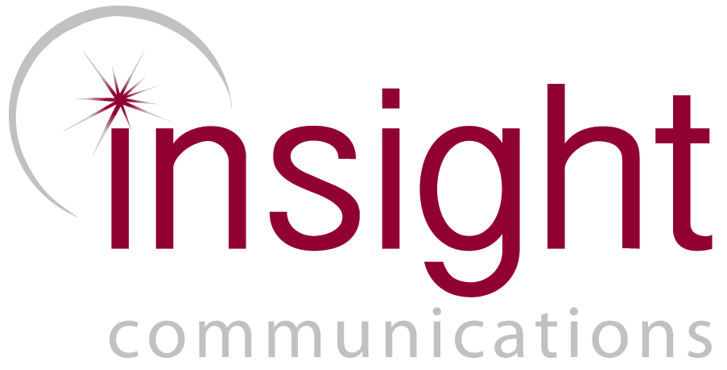
MEDIA RELEASE: 10 April 2017

Sydney Publicist Named Among World-Leading Young Professionals

Alice Collins, founding Director of Sydney based boutique PR agency, Insight Communications, has been named among six finalists globally for the Young Professional of the Year Award 2017, in the International Association for Measurement and Evaluation of Communication (AMEC) Awards.

The industry’s prestigious annual AMEC Awards recognise excellence in communication, measurement, evaluation and media intelligence; while AMEC’s Young Professional of the Year Award acknowledges the outstanding contribution of young professionals who demonstrate considerable promise as future industry leaders.

The rigorous judging criteria and a record number of entries makes the competition for an AMEC Award fierce among media intelligence and PR agencies competing on a global scale for the industry’s most distinguished gong.

However, Barry Leggetter, CEO of AMEC, said, “Being shortlisted is a ‘win’ in its own right because it shows that the work is outstanding on a truly international level.”

Clare Collins, Managing Director of Insight Communications said, “This recognition is well deserved distinguishing Alice and the other 5 finalists as being among the best in their field on a global scale and we extend our heartfelt congratulations to them all.

“For Alice and Insight, it is an incredible professional achievement to receive this level of international recognition from esteemed peers; particularly as Alice is the only finalist from a PR agency (and a small one at that) amid a field of respected media analysts, many representing multinational media intelligence agencies.

“When a director of a boutique PR agency is named among this select group of dedicated young professionals in what is an extremely competitive international field; it is testimony to the fact that when it comes to delivering the highest standard of professional practice in communication, it’s not the size of the agency that counts.

“It gets down to the people behind the work; their passion for excellence, ethics and, dedication to the profession, their clients and the organisations they represent that empowers any agency, large or small, to consistently shine.

“It’s these qualities and Alice’s extraordinary level of professionalism in going above and beyond to exceed expectations that underpins Insight’s core philosophy and methodologies driving us to consistently produce exceptional, measureable multi-award winning campaigns that deliver benefits to society.”

“Achieving this standard of excellence, often on limited budgets is largely due to Alice’s commitment to ethical, valuable, communication, demonstrated through effective measurement and evaluation,” Ms Collins said.

Between 2010 and 2016, Alice and Insight have received 14 peer reviewed Australian and international awards including 12 Public Relations Institute of Australia (PRIA) Awards. Insight was also Australia’s first PR agency to receive an AMEC and Global Alliance COMM PRIX Award in 2014 with Alice the youngest communication professional to receive these awards at that time.

“Being a finalist for the AMEC Young Professional of the Year Award 2017 acknowledges Alice’s passion and commitment to consistently deliver the highest standard of professionalism for all Insight clients,” said Ms Collins.

Winners will be announced at the AMEC Awards presentation event in Bangkok, during the AMEC Global Summit on the evening of Wednesday 17th May attended by communication experts from more than 25 countries.

-ENDS-

For all media enquiries please contact Insight Communications: 02 9518 4744

Finalists for the AMEC Young Professional of the Year 2017

- CARMA - Mania Abboud (Senior Relationship Manager, CARMA, Dubai, UAE) - A multinational media intelligence agency with 13 international offices covering 80 languages and 41 countries globally.
- Infomedia - Lasse Skjoldan (Senior Advisor, Infomedia, Copenhagen) - The leading Danish media intelligence agency.
- Insight Communications – Alice Collins (Director, Insight Communications, Sydney, Australia) - A multi-award winning public relations agency specialising in cause, culture, community and health campaigns throughout Australia.
- Insentia - Alex Gyde (Senior Analyst, Insentia, Wellington and Wairarapa, New Zealand) - An Australian based multinational media monitoring and analysis agency with 18 offices across Asia-Pacific, Europe and the US.
- Kantar Media - Georgie Bents (Research Consultant. Kantar Media, WPP, London, UK) - A global media and market research company with offices in the UK, Ireland, Europe and the USA.
- Mediaverse - Sally Chadwick (Senior Account Manager, Mediaverse, Melbourne, Australia) - The media research and analysis division of Australian Associated Press (AAP).

The full list of AMEC Award finalists can be found here: http://amecawards.com/amec-awards-2017-shortlist/

Alice Collins MPRIA, Founding Director, Insight Communications
Alice Collins commenced her career working with Australia’s leading Arts Publicist, the Late Judith Johnson. In 2008, Alice went on to become a founding Director of Insight Communications, a full service PR agency specialising in developing and delivering awareness campaigns throughout Australia for the cause, culture community and health sectors.
Alice and her Sydney based agency have received national and international peer recognition winning 12 PRIA awards (2010 to 2016) and 2 international awards, AMEC International Communication Effectiveness Award (2014); and, were Australia’s first recipients of a Global Alliance COMM PRIX Award (2014).
Insight’s campaigns have also been recognised in NSW and Federal Parliaments multiple times as having made significant contributions to Australian communities.
Since 2010, Alice has been a regular presenter on effective social campaign management at UTS and in 2014 and 2016 Alice Collins was a nominated finalist for the UTS Alumni of the Year Awards in the Faculty of Arts and Sciences for her contribution to her industry and the broader community.
Alice and Insight’s multi-award winning peer reviewed campaigns include; the Asbestos Awareness Campaign (government) Ovarian Cancer Awareness Month (health and NFP) and their pro-bono campaign, Where’s William? (Community), which also received recognition from Crime Stoppers NSW in 2015.
Alice holds a Bachelor of Communications (Media, Arts and Production) from the University of Technology, Sydney where she majored in Film Production and minored in Journalism and Advertising.

Insight Communications

Web: http://www.insightcommunications.net.au/
Facebook: https://www.facebook.com/insightcommunicationsaustralia/

